Pinged successfully the Windows Server 2019 from the Windows 10 VM.

Pinged successfully the Ubuntu VM from Windows 10 VM.

Pinged successfully the Windows Server 2019 from the Ubuntu VM.

Pinged successfully Windows 10 from the Ubuntu VM.

Pinged successfully the Ubuntu VM from the Windows Server 2019.

Pinged successfully Windows 10 VM from the Windows Server 2019.

Windows Server 2019 device name.

Windows Server 2019 IP address highlighted.

Windows 10 device name highlighted.

Windows 10 IP address highlighted.

Ubuntu VM hostname.

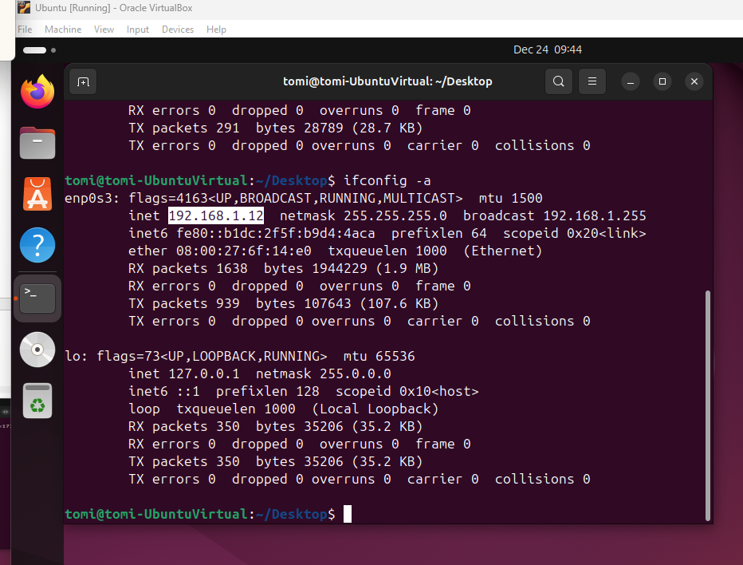

Windows 10 IP address highlighted.